**MS SQL Assignment 1 using Adventure Works MSSQL Database**

1. **Using FactInternet Sales:**

**1.Write SQL queries to show data by Year / Quarter / Month?**

**QUERY:**

select datename(Year,orderdate) as [year],concat('Q',datename(Quarter,orderdate)) as [Quarter],concat(datename(month,orderdate),'-',datename(Year,orderdate))as [month],sum(SalesAmount) as [TotalSalesAmount]

from FactInternetSales

Group by datename(Year,orderdate),datename(Quarter,orderdate),datename(month,orderdate)

order by datename(Year,orderdate),datename(Quarter,orderdate),datename(month,orderdate)

**OUTPUT:**

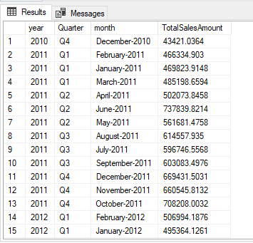

**2.Write a SQL query to show the Sales by top 10 Product?**

**QUERY:**

select * from [dbo].[DimProduct]

select top 10 [dbo].[DimProduct].EnglishproductName , floor(sum(SalesAmount)) as sales

from FactInternetSales

INNER JOIN [dbo].[DimProduct]

on [FactInternetSales].ProductKey=[dbo].[DimProduct].ProductKey

group by EnglishproductName

Order by sum(SalesAmount) desc

**OUTPUT:**

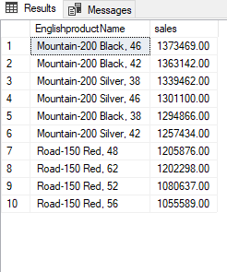

1. **Write a SQL query to show the Sales by Territory Group / Country / Region (filter data using a variable)?**

**QUERY:**

select* from FactInternetSales

select * from [dbo].[DimSalesTerritory]

select[dbo].[DimSalesTerritory].SalesTerritoryGroup ,[dbo].[DimSalesTerritory].SalesTerritoryCountry ,[dbo].[DimSalesTerritory].SalesTerritoryRegion,sum(SalesAmount) as Total_sales

from [dbo].[DimSalesTerritory]

inner join FactInternetSales

On [dbo].[DimSalesTerritory].SalesTerritoryKey = FactInternetSales.SalesTerritoryKey

group by SalesTerritoryGroup,SalesTerritoryCountry,SalesTerritoryRegion

order by sum(SalesAmount) desc

**OUTPUT:**

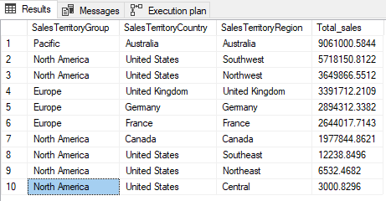

**4.Write a SQL query to show the Sales Amount, (Sales Amount - Tax Amount - Freight)?**

**QUERY:**

select floor(sum(SalesAmount)) as Sales_amount , floor(sum(SalesAmount-TaxAmt-Freight)) as Exact_salesamount

from FactInternetSales

**OUTPUT:**

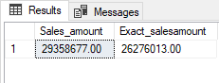

**5.Write a SQL query to show Time taken to Ship from Order Date?**

**QUERY:**

select OrderDate,ShipDate,

datediff(Day,OrderDate,ShipDate) as Timetaken_days

from FactInternetSales

**OUTPUT:**

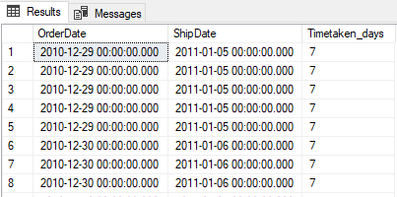

1. **Using FactFinance:**

**1.Write a SQL query to show values for each Percentage of Ownership**

**QUERY:**

select OrganizationName , PercentageOfOwnership,sum(Amount) as sales

from [dbo].[FactFinance]

inner join [dbo].[DimOrganization]

on [dbo].[FactFinance].OrganizationKey=[dbo].[DimOrganization].OrganizationKey

group by OrganizationName , PercentageOfOwnership

order by sales desc

OUTPUT:

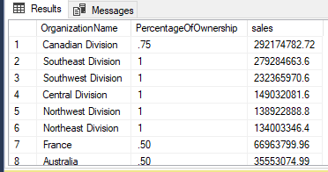

**2.Write SQL queries to show the Amount by Quarter, Month-Year, Week ?**

**QUERY:**  
select concat('Q',datename(Quarter,[Date]))as Quarter, concat(datename(month,[Date]),'-',datename(year,[Date]))as month_year, datename(week,Date) as week,floor(sum(Amount)) as amount

from FactFinance

group by datename(Quarter,[Date]),datename(month,[Date]),datename(year,[Date]),datename(week,Date),[Date]

order by [Date] asc

**QUTPUT:**

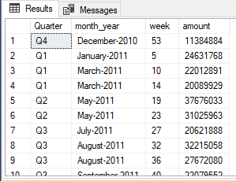

**3.Write a SQL query to show the Amount by Currency and restrict the result with top 5 ?**

**QUERY:**

select * from [dbo].[DimCurrency]

select* from [dbo].[DimOrganization]

SELECT Top 5 CurrencyName ,floor(sum(Amount))as Amount

from FactFinance

join [dbo].[DimOrganization]

on FactFinance.OrganizationKey = [dbo].[DimOrganization].OrganizationKey

join [dbo].[DimCurrency]

on [dbo].[DimCurrency].CurrencyKey =[dbo].[DimOrganization].CurrencyKey

group by CurrencyName

order by sum(Amount) desc

**OUTPUT:**

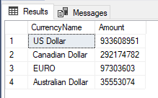

1. **Write SQL queries to show the Amount by Organization / Department / Scenario / Account and display the result with high value on the top?**

**QUERY:**

select* from [dbo].[DimOrganization]

select* from [dbo].[FactFinance]

select* from [dbo].[DimDepartmentGroup]

select* from [dbo].[DimScenario]

select* from [dbo].[DimAccount]

select OrganizationName,DepartmentGroupName,ScenarioName,AccountDescription,floor(SUM(Amount)) as amount

from [dbo].[FactFinance]

join [dbo].[DimOrganization]

on [dbo].[FactFinance].OrganizationKey =[dbo].[DimOrganization].OrganizationKey

join [dbo].[DimDepartmentGroup]

on [dbo].[FactFinance].DepartmentGroupKey =[dbo].[DimDepartmentGroup].DepartmentGroupKey

join [dbo].[DimScenario]

on [dbo].[FactFinance].ScenarioKey =[dbo].[DimScenario].ScenarioKey

join [dbo].[DimAccount]

on [dbo].[FactFinance].AccountKey = [dbo].[DimAccount].AccountKey

group by OrganizationName,DepartmentGroupName,ScenarioName,AccountDescription

order by SUM(amount)DESC

**OUTPUT:**

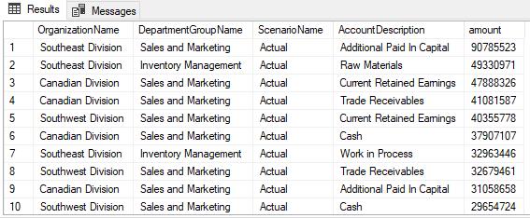

**C.Using FactCallCenter:**

**1.Write a SQL query to show # of Calls, # of Issues Raised, # of Total Operators?**

**QUERY:**

select sum(calls)as calls,sum(IssuesRaised) as Issuesrasised,sum(TotalOperators) as TotalsOperators

from [dbo].[FactCallCenter]

**OUTPUT:**

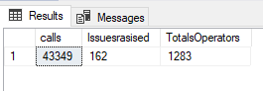

**2.Write a SQL query to show the Daily # of Calls by Shift and display the result with recent date should be visible first ?**

**QUERY:**

select FORMAT([Date],'MM/dd/yyyy') as date,[Shift], sum(Calls)as calls

from [dbo].[FactCallCenter]

group by [Shift],FORMAT([Date],'MM/dd/yyyy')

order by FORMAT([Date],'MM/dd/yyyy')desc

**OUTPUT:**

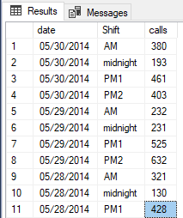

**3.Write a SQL query to compare the # of Calls, Average of AverageTimePerIssue between Weekday and Holiday by Month?**

**QUERY:**

select concat(datename(year,[Date]),'-',datename(month,[Date])) as [Month],WageType,Avg(AverageTimePerIssue) as AverageTimePerIssue,sum(Calls)as calls

from [dbo].[FactCallCenter]

group by WageType,concat(datename(year,[Date]),'-',datename(month,[Date]))

**QUTPUT:**

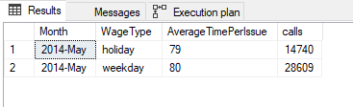

1. **Using FactSurveyResponse**

**1.Write a SQL query to show gender wise # of response**?

**QUERY:**

select * from [dbo].[DimCustomer]

select Gender,count(SurveyResponseKey) as SurveyResponseKey

from [dbo].[FactSurveyResponse]

inner join [dbo].[DimCustomer]

on [dbo].[FactSurveyResponse].CustomerKey = [dbo].[DimCustomer].CustomerKey group by Gender

**OUTPUT:**

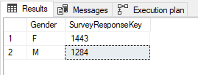

**2.Write a SQL query to show # of Customer based on their First Purchase Date?**

**QUERY:**

select DateFirstPurchase ,Count(CustomerKey) as customer

from [dbo].[DimCustomer]

group by DateFirstPurchase

order by DateFirstPurchase asc

**OUTPUT:**

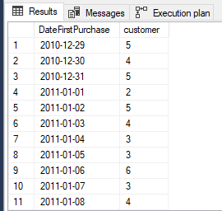

**3.Write a SQL query to compare # of Product by Gender, Marital Status by month-year?**

**QUERY:**

select concat(datename(month,[Date]),'-',datename(year,[Date])) as [month-year] ,Gender,MaritalStatus,count(EnglishProductCategoryName)as product

from [dbo].[FactSurveyResponse]

inner join [dbo].[DimCustomer]

on [dbo].[FactSurveyResponse].CustomerKey = [dbo].[DimCustomer].CustomerKey

group by concat(datename(month,[Date]),'-',datename(year,[Date])),Gender,MaritalStatus,[date]

order by [date] asc

**OUTPUT:**

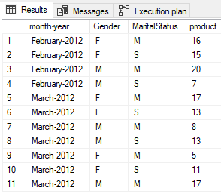

**4.Write a SQL query to show # of Product by Age Range <16, 16-25, 26-40, >40 ?**

**QUERY:**

select (case

when datediff(year,BirthDate,getdate()) <16 then '<16'

when datediff(year,BirthDate,getdate()) between 16 and 25 then '16-25'

when datediff(year,BirthDate,getdate()) between 26 and 40 then '26-40'

when datediff(year,BirthDate,getdate()) >40 then '>40'

END) as age_range,count(EnglishProductCategoryName)as product

from [dbo].[FactSurveyResponse]

inner join [dbo].[DimCustomer]

on [dbo].[FactSurveyResponse].CustomerKey = [dbo].[DimCustomer].CustomerKey

group by

(case

when datediff(year,BirthDate,getdate()) <16 then '<16'

when datediff(year,BirthDate,getdate()) between 16 and 25 then '16-25'

when datediff(year,BirthDate,getdate()) between 26 and 40 then '26-40'

when datediff(year,BirthDate,getdate()) >40 then '>40'

END)

**OUTPUT :**

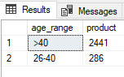

1. **Using FactProductInventory**

**1.Write a SQL query to show # of Units Balance, List Price Value of Units Balance based on (or date selected using a variable)**

**QUERY:**

select ListPrice, sum(UnitsBalance) as UnitsBalance , concat(datepart(mm,[EndDate]),'-',datename(day,[EndDate]),'-',datename(year,[EndDate]))as [Date]

from [dbo].[FactProductInventory]

inner join [dbo].[DimProduct]

on [dbo].[FactProductInventory].ProductKey = [dbo].[DimProduct] .ProductKey

where listPrice > 0

group by ListPrice,concat(datepart(MM,[EndDate]),'-',datename(day,[EndDate]),'-',datename(year,[EndDate])),[EndDate]

having [EndDate] >0

order by concat(datepart(mm,[EndDate]),'-',datename(day,[EndDate]),'-',datename(year,[EndDate])) asc

**QUTPUT:**

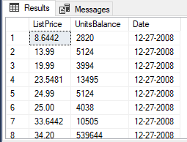

**3.Write a SQL query to compare Standard Cost, List Price, Dealer Price for top 5 Finished Goods based on Units Balance**

**QUERY:**

select top 5 EnglishProductName, StandardCost,ListPrice,DealerPrice,sum(UnitsBalance) as [Finished Goods]

from [dbo].[DimProduct]

inner join [dbo].[FactProductInventory]

on [dbo].[DimProduct].ProductKey = [dbo].[FactProductInventory].ProductKey

where [FinishedGoodsFlag]>=1

group by StandardCost,ListPrice,DealerPrice, EnglishProductName

order by sum(UnitsBalance) desc

**OUTPUT:**

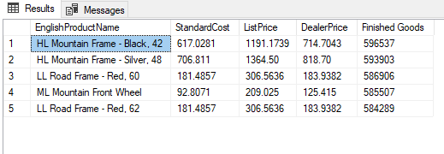

**4.Write a SQL query to show the top 10 least product based on out movement**

**Query:**

select top 10 EnglishProductName , sum(UnitsOut) as out_movement

from [dbo].[FactProductInventory]

inner join [dbo].[DimProduct]

on [FactProductInventory].ProductKey = [dbo].[DimProduct] .ProductKey

group by EnglishProductName

having sum(UnitsOut) >0

order by sum(UnitsOut) asc

**QUTPUT:**

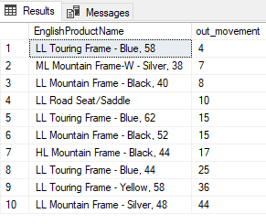

**F.Using FactSalesQuota**

**1.Write a SQL query to show the Sales Amount Quota by Year and on selection of year show the same chart by Quarter and then by Month when the Quarter is selected.**

**QUERY:**

select concat(datename(month,[Date]),'-',datename(year,[Date])) as Month_Year ,concat('Q',datename(Quarter,[Date])) as Quarter,sum(SalesAmountQuota) as SalesAmountQuota

from [dbo].[FactSalesQuota]

group by concat(datename(month,[Date]),'-',datename(year,[Date])) ,concat('Q',datename(Quarter,[Date])),[Date]

order by [Date] desc

**OUTPUT :**

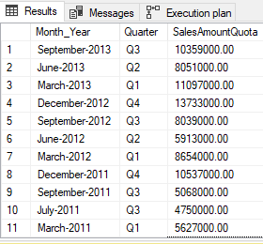

**2.Write SQL queries to show the Sales Amount Quota by Employee's Department and by Employee**

**QUERY:**

select concat(FirstName,LastName) as Employee ,DepartmentName,sum(SalesAmountQuota) as SalesAmountQuota

from [dbo].[FactSalesQuota]

inner join [dbo].[DimEmployee]

on [dbo].[FactSalesQuota].EmployeeKey=[dbo].[DimEmployee].EmployeeKey

group by FirstName, LastName,DepartmentName

order by sum(SalesAmountQuota) desc

**OUTPUT:**

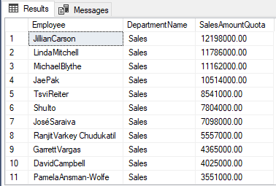

1. **Write a SQL query to show the Sales Amount Quota by Parent Employee - second level employee's – Year – Quarter - Month**

**QUERY:**

select (FirstName) as ParentEmployee ,datename(year,[Date]) as [Year],concat('Q',datename(Quarter,[Date])) as [Quarter],datename(Month,[Date])as[Month],(SalesAmountQuota) as SalesAmountQuota

from [dbo].[FactSalesQuota]

inner join [dbo].[DimEmployee]

on [dbo].[FactSalesQuota].EmployeeKey=[dbo].[DimEmployee].EmployeeKey

group by datename(year,[Date]),datename(Quarter,[Date]),datename(Month,[Date]),FirstName,SalesAmountQuota

**QUTPUT:**

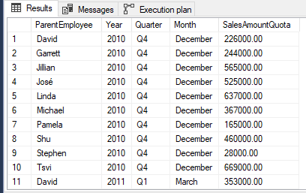

1. **Write a SQL query to show the following Employee details::First Name, Last Name, Gender (Male/Female), Hire Date,Department, Sales Territory Region, Vacation Hours, (Vacation Hours * Base Rate)**

**QUERY:**

SelectFirstName,LastName,Gender,HireDate,DepartmentName,SalesTerritoryRegion,VacationHours, (VacationHours*BaseRate) as [Vacation Hours * Base Rate]

from [dbo].[DimEmployee]

inner join [dbo].[DimSalesTerritory]

on [dbo].[DimEmployee].[SalesTerritoryKey] =[dbo].[DimSalesTerritory].[SalesTerritoryKey]

group by FirstName,LastName,Gender,HireDate,DepartmentName,SalesTerritoryRegion,VacationHours, (VacationHours*BaseRate)

**OUTPUT:**

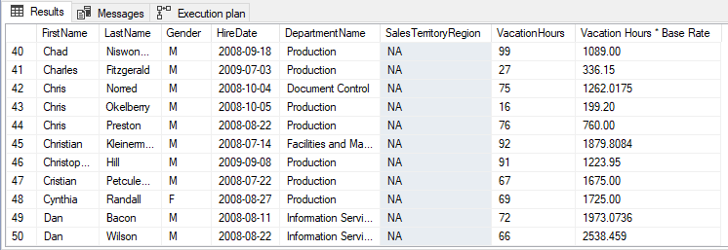

1. **Write a SQL query to show the Sales Amount Quota by Employee's Age Range (buckets <=30, 31-40, 41-50, >50)**

**QUERY:**

select (case

when datediff(year,BirthDate,getdate()) <=30 then '<=30'

when datediff(year,BirthDate,getdate()) between 31 and 40 then '31-40'

when datediff(year,BirthDate,getdate()) between 41 and 50 then'41-50'

when datediff(year,BirthDate,getdate()) >50 then '>50'

END) as [age_range],sum(SalesAmountQuota) as [Sales Amount Quota]

from [dbo].[DimEmployee]

inner join [dbo].[FactSalesQuota]

on [dbo].[DimEmployee].EmployeeKey=[dbo].[FactSalesQuota].EmployeeKey

group by (case when datediff(year,BirthDate,getdate()) <=30 then '<=30'

when datediff(year,BirthDate,getdate()) between 31 and 40 then '31-40'

when datediff(year,BirthDate,getdate()) between 41 and 50 then'41-50'

when datediff(year,BirthDate,getdate()) >50 then '>50'

END)

**OUTPUT:**

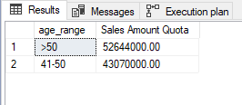The End…